Calculate and visualize bundles

Feature request specification

Authors:

|  |  |  |
| --- | --- | --- |
| Name | Changes | Date |
| Thomas Grieser | Initial creation | 17.09.13 |
| Fabian Kliemannel | Changed UI figures | 19.09.13 |
| Martin Rüsseler | Added Sw module overview | 03.06.14 |

Concerned software tool:

E/E-Browser

Content

1. General description 3

2. How bundles are calculated 4

2.1. Routing Information 4

2.2. Calculation method 4

2.3. Diameters of individual cables/wires 4

External configuration file for diameters 4

Diameters taken from KBL file 5

Generic diameters 5

2.4. Colors for cables/wires 5

3. Realization in E/E Browser 6

4. User interface proposal 7

# General description

This specification is about enabling E/E-Browser to calculate diameter of bundles at user specified positions. Position is given by selecting a segment.

Functionality shall be able to calculate/visualize bundles of all specified variants (module configurations).

In addition the current module configuration (if not a specified variant) has to be calculated/visualized.

The Cross Section Area Information from KBL has to be displayed.

Calculating/Visualizing bundles will add benefits to E/E-Browser:

* User is able to check, if a bundle exceeds given restrictions.  
  (e.g. if fits into a cable channel or grommet)
* Visualization will help with plausibility checks.
* Calculation for all predefined variants will save lots of time as module settings do not have to be changed manually.

# How bundles are calculated

## Routing Information

This data can be taken from KBL file. Combined with module dependencies, E/E-Browser is able to determine the cables/wires for a given segment and module configuration.

## Calculation method

The circle-in-circle method is used for calculating bundles diameters.

## Diameters of individual cables/wires

There are different sources for this information:

1. An external configuration file listing diameters of cables/wires along with part numbers
2. The values for outer diameters taken from KBL file
3. A generic value. Calculating the outer diameter of a wire by its conductors CSA

The algorithms should try to get information along this sequence. Generic calculation is the last ‘fallback’ option. Data source has to be visualized for the user.

### External configuration file for diameters

On startup of E/E-Browser the following folder-structure has to be created automatically, if not existing:

%appdata%\Intedis\EE-Browser\UserAddOns\

Within this folder there **might be** an xml file called

DiameterSettings.xml

This file holds data for outer diameters:

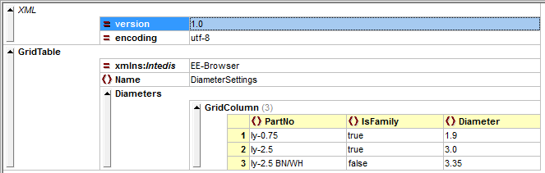

* PartNo string  
  of a wire or cable. If declared as ‘IsFamily’, this field contains the beginning of a family of PartNumbers. (e.g. same diameters but different in colors)
* IsFamily [true/false]  
  If set ‘true’, KBLs part numbers have to begin with specified PartNo of this record.  
  If set ‘false’, KBLs part number have to match exactly specified PartNo.
* Diameter decimal  
  Outer diameter of cable/wire in mm. A dot ‘.’ Is used for decimals.

In the example above there is a family (row 2) and an individual specification (row 3). It is important, to first look after exact matches and in a second step looking for a matching family. Exact matches do always have the highest priority!

### Diameters taken from KBL file

This will be the most common case. Just take the outer diameter of a wire/cable from the KBL file.

### Generic diameters

The fallback solution: These formulas have to be used for calculating the outer diameters:

MulticoreDiameter = (1.49 / ([NOF_ACCUMULATED_DIAMETERS] ^ 0.52)) *

[ACCUMULATED_DIAMETERS] * 1.1

Faktoren MC1 bis MC3

WireDiameter = 0.4+0.055*[CSA]+1.6259*[CSA]^0.4943]

Faktoren W1 bis W4

## Colors for cables/wires

Colors and their codes are defined within E/E-Browser Settings -> General settings on tab ‘Color codes’.

This information is used for sketching the bundle pictures.

# Realization in E/E Browser

As variant settings might change during runtime, it does not make sense to calculate all bundles of a HCV container at once. Best way is to calculate bundles and their visualization at demand on the fly. This should be doable with acceptable waiting times.

This must be checked more closely and at least some asynchronous processing is necessary as this could take some time at least on big segments.(Cockpit…)

Information tables should not be changed at all. They are showing up KBL content. Messing up these properties with calculated ones seems to be a bad idea.

Entry point should be a segments context menu:

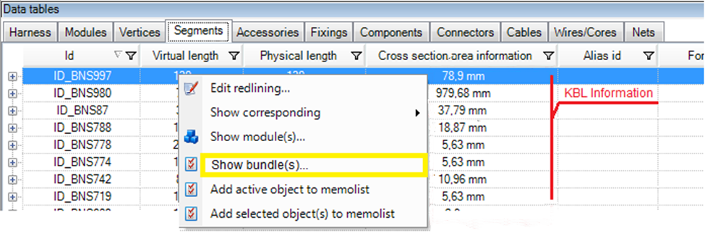

A **modal dialog** will open up when clicking this new option.

# User interface proposal

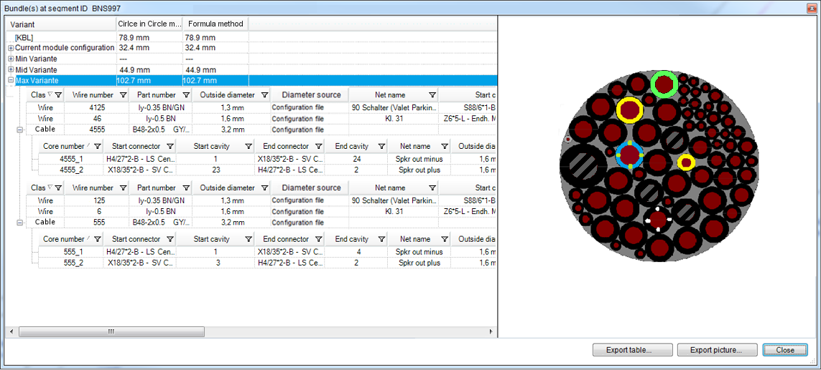

The modal dialog consists of two main parts:

* A table showing up the variants and calculated bundle diameter  
  sub tables below showing wires/cables, some info and the diameter source
* A visualization of the currently selected variant

Dialog details:

* There is a movable splitter between those two areas.
* A maximize-button (top/right) has to be added.
* Double click on top of window will maximize dialog.
* There is a roundtrip between table (cables/wires) and the graphics and vice versa.
* Export table … will pop up a file dialog. Table will be saved as Excel workbook.   
  Filename has a preset: <segment_Id>_bundles.xlsx/xls
* Export picture … will export current bundle picture in various graphic formats.  
  Filename has a preset: <segment_Id>_<variant_name>_bundle.jpg/bmp/…
* Picture export is **not** possible if
  + No variant has been selected
  + [KBL] is selected
* Export-button has to be grayed out if not functional.
* If variant [KBL] is selected, the picture just shows a message ‘no picture available’.
* Visualization shows up real colors taken from settings.
* Visualization does not show up cores of cables. This is not possible, as we don’t know the layout of the cable. (E.g. coaxial, twisted, …). Cables should be shown without ‘copper’ but with a hash inside to have a visible difference to normal wires.
* ‘Close’ will close the dialog.

# Which software modules can be used

Circle Packager

How do we handle the multicores if we have no entries in the database found? We could use the generic calculation again..

What are the limits regarding performance in here?

It seems to be reasonable to store once calculated results in the data structure as long as we think of the predefined module configurations. If we do so, we need to identify changes of the configuration to tag the result dirty and initiate a recalculate. A possibility to initiate an entire discard of all results might be reasonable to allow changes of entries in the database file, or we can detect that by timestamp?

Bundle Drawer

As we are not sketching the inner part of multicores, there are some minor changes necessary.

Its seems easier to make a new small component, but nevertheless it would be helpful if we could reuse this later on, so issues like cores in cores and screen / shields are necessary

Being on a segment, we need to check whether the bundle data is valid. That means, the final diameter and the circle package object structure is valid. The picture and drawing can be regenerated each time the form is opened. Each segment along with the predefined module settings needs to keep a result set and possibly also the current setting has such a set. If the data is valid it can be displayed and pictures are generated for the selected configuration.

If the data is not valid it needs to be recalculated first. (we may think about recalculating the entire set of configurations on a given segment, or we do this only if the user selects a configuration on a segment, which is faster in the beginning). The results are kept in the model locally.

The calculation needs to retrieve the current wires and cables for the given configuration and segment. For each wire respectively cable, we must find appropriate diameter values, either form the data base file or the entries from the kbl. Along with the color information these data can be supplied to the circle packager.

Any modification of the check boxes of a given configuration needs to tag the results dirty on all segments / Configuration result data sets.

In case we use generic calculation, we need to define the formulas somehow, and this should not be hardcoded. Either an assembly holds these calculation that we can easily exchange (strongname!!) or we need some other way similar to the process catalog using the code DOM.

